Student Project

ECG Dicom Viewer
Student or Student-Team (max. 3 Persons)
- Period
March –Juni 2010
- Titel: Concept & development of Dicom Viewer for ECG
Goal of this project is to develop a Dicom viewer, which is capable to show Dicom ECG Waveform and Dicom Encapsulated PDF.
  - Dicom Viewer Features:
The following functions should be in this viewer: Visualization of Dicom ECG should be the scope of the work
Dicom ECG Waveform:
Display of Patient data & ECG Waveform display:
In terms of ECG Waveforms it should support 2 SOP Classes (see DCS):
- General ECG Waveform SOP Class (support 3, 6, 12, 15 leads, independent from display format)
- 12-Lead ECG Waveforms SOP Class (12 leads, supports different display formats e.g. 4x2,5s, 2x5s).
The viewer should support both objects. It's content is explicitly described in the DICOM Standard.
Dicom Encapsulated PDF: Standard function

If possible and easier to get it done the tool can use components from Free or Share ware like e.g. the Offis tools (http://dicom.offis.de/index.php.de)

If you have questions please contact:
Prof. Dr. Christian Johner Dipl. Ing. (FH) Christian Urban
email: mail@johner.org eMail: christian.urban@ge.com

- Prouct Details
http://www.gehealthcare.com/eude/cardiology/products/diagnostic_ecg/resting_stress/cardiosoft/index.html

- Supported Dicom formats on CardioSoft

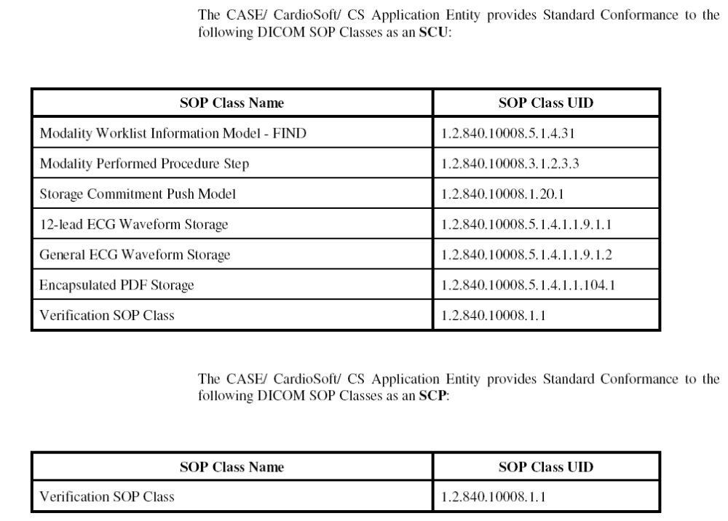

DICOM Conformance Statements
http://www.gehealthcare.com/usen/interoperability/dicom/docs/2040396-087_Rev_A_CASE_V6.6.pdf

